1. **UK DIAGNOSTIC IMAGING DEVICES MARKET**

**by Product Type** (X-ray Imaging Systems, Computed Tomography (CT) Scanners, Magnetic Resonance Imaging (MRI) Systems, Ultrasound Systems, Nuclear Imaging Systems (PET/SPECT), Mammography Systems, Others). **by Application** (Cardiology, Oncolog, Neurology, Orthopedics, Obstetrics & Gynecology, Other Applications). **by End User (**Hospitals, Diagnostic Imaging Centers, Ambulatory Surgical Centers (ASCs), Research and Academic Institutes). **by Region (**England, Scotland, Wales, Northern Ireland). Global and Regional Industry Overview,Market Intelligence, Comprehensive Analysis, Hystorical Data, and forecastes 2024-2032.

According to Intelli, the UK diagnostic imaging devices market was valued at USD 1,840 million in 2024 and is projected to reach USD 2695.61 million by 2032, growing at a CAGR of 5.79% from 2024 to 2032.

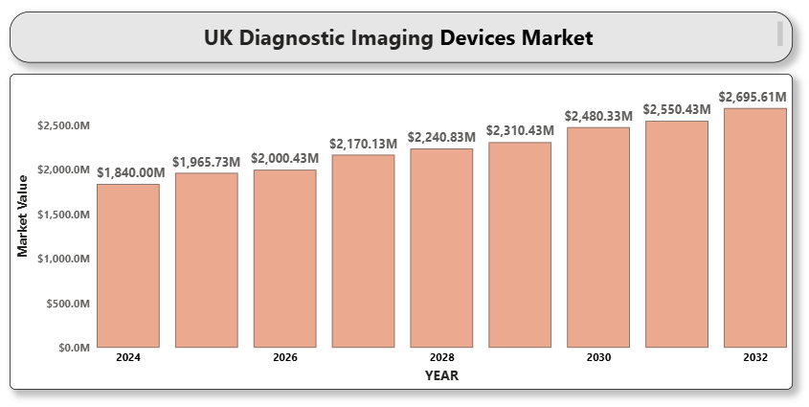

1. **Switzerland Endoscopy Devices Market**

**By Product Type (**Flexible Endoscopes, Rigid Endoscopes, Capsule Endoscopes, Disposable Endoscopes, Robot-Assisted Endoscopes, Visualization Systems (Camera, Light Source, Display), Endoscopic Accessories (Biopsy forceps, Trocars, Insufflators). **By Application (**Gastrointestinal Endoscopy, Laparoscopy, Arthroscopy, Urology Endoscopy, ENT Endoscopy, Gynecology Endoscopy, Bronchoscopy, Others). **By End User (**Hospitals, Ambulatory Surgical Centers, Specialty Clinics, Academic & Research Institutions. **By Region (**German-speaking Switzerland (Zurich, Basel, Bern), French-speaking Switzerland (Geneva, Lausanne), Italian-speaking Switzerland (Ticino). Global and Regional Industry Overview, Market Intelligence, Comprehensive Analysis, Hystorical Data, and forecastes 2024-2032.

According to Intelli, the Switzerland endoscopy devices market was valued at USD 152.0 million in 2024 and is projected to reach USD 214.33 million by 2032, growing at a CAGR of 6.85% from 2024 to 2032.

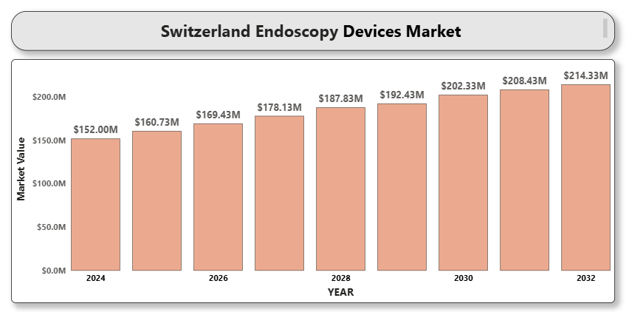

1. **SWEDEN ORTHOPEDIC DEVICES MARKET**

**By Product Type (** Joint Reconstruction Devices, Spinal Devices, Trauma Fixation Devices, Orthobiologics, Arthroscopy Devices, Others). **By Application (**Hip Replacement, Knee Replacement, Spine Disorders, Sports Injuries, Other Applications). **By End User (**Hospitals, Orthopedic Clinics, Ambulatory Surgical Centers, Research and Academic Institutes. **By Region (**Northern Sweden, Central Sweden, Southern Sweden). Global and Regional Industry Overview, Market Intelligence, Comprehensive Analysis, Hystorical Data, and forecastes 2024-2032.

According to Intelli, the Sweden orthopedic devices market was valued at USD 271.8 million in 2024 and is projected to reach USD 330.62 million by 2032, growing at a CAGR of 3.38% from 2024 to 2032.

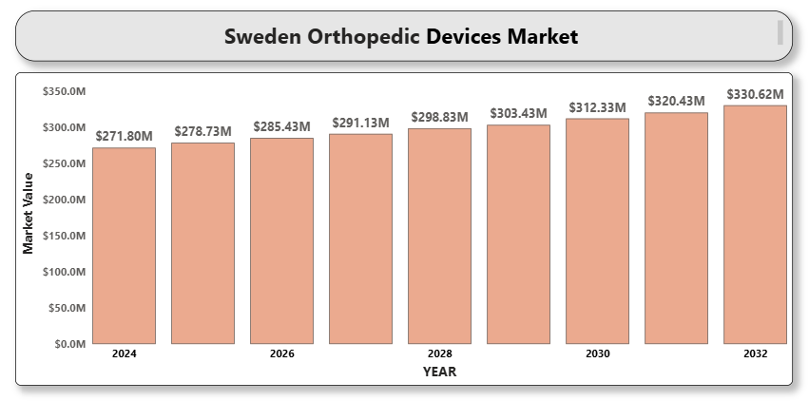

1. **SPAIN TELEMEDICINE MARKET**

**By Component** (Software, Hardware, Services). **By Mode of Delivery** (Web-based, Cloud-based, On-premise). **By Application** (Teleradiology, Telepathology, Telecardiology, Telepsychiatry, General Consultation). **By End User** (Hospitals, Homecare Settings, Clinics, Others **(**Insurance Providers, Pharmacies). **By region** (Central Spain, Northeastern Spain, Eastern Spain, Northern Spain). Global and Regional Industry Overview, Market Intelligence, Comprehensive Analysis, Hystorical Data, and forecastes 2024-2032.

According to Intelli, the Spain Telemedicine Market was valued at USD 3,670 million in 2024 and is projected to reach USD 9289.33 million by 2032, growing at a CAGR of 13.21% during the forecast period.

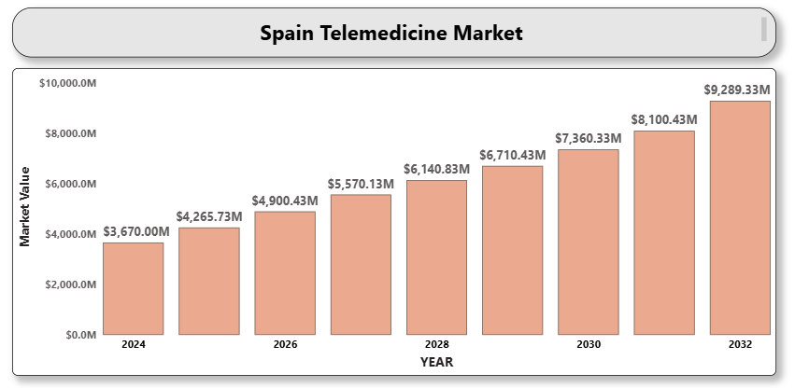

1. **Spain Respiratory Devices Market**

**By Product Type** (Therapeutic Devices, Monitoring Devices, Diagnostic Devices). **By Application** (Asthma, COPD, Sleep Apnea, Infectious Diseases). **By End-user** (Hospitals, Homecare Settings, Clinics, Ambulatory Centers). **By Region** (Madrid, Barcelona, Valencia, Andalusia, Rest of spain). Global and Regional Industry Overview, Market Intelligence, Comprehensive Analysis, Hystorical Data, and forecastes 2024-2032.

According to Intelli, the Spain Respiratory Devices Market was valued at approximately USD 1,173.3 million in 2024 and is projected to reach USD 1624.24 million , growing at a compound annual growth rate (CAGR) of 5.05% during the forecast period of 2024-2032.

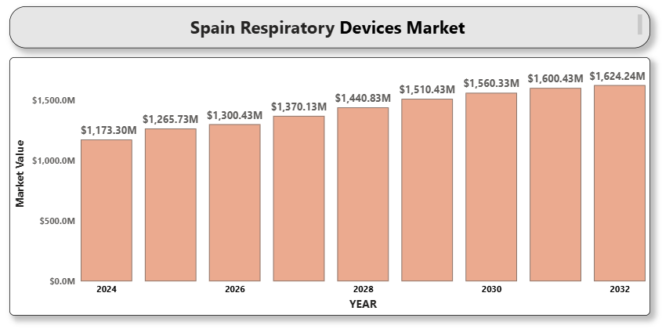

1. **SPAIN ORTHOPEDIC DEVICES MARKET**

#### By Product Type (Joint Replacement Devices, Spinal Implants, Trauma Devices, Orthobiologics, Other Devices). By End-User (Hospitals, Orthopedic Clinics, Ambulatory Surgical Centers (ASCs)). By Technology (Robotic-Assisted Surgery, 3D Printing, Minimally Invasive Surgery (MIS)). By Application (Joint Replacement, Spinal Surgery, Trauma Surgery, Other Applications). Global and Regional Industry Overview, Market Intelligence, Comprehensive Analysis, Hystorical Data, and forecastes 2024-2032.

According to Intelli, the Spain orthopedic devices market was valued at USD 1,230 million in 2024 and is projected to reach USD 1729.06 million by 2032, growing at a CAGR of 5.25% from 2024 to 2032.

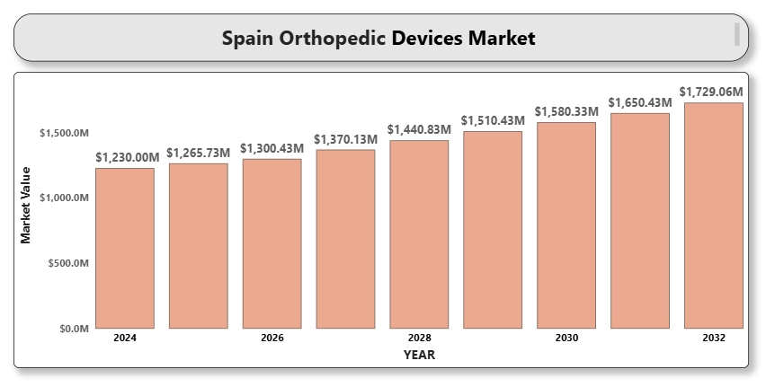

1. **SPAIN ENDOSCOPY DEVICES MARKET**

**By Product Type** (Endoscopes, Visualization Systems, Operative Devices, Other Accessories). **By End-User** (Hospitals, Ambulatory Surgical Centers (ASCs), Specialty Clinics). **By Technology** (Flexible Endoscopes, Rigid Endoscopes, Capsule Endoscopy). **By Application** (Gastrointestinal (GI) Endoscopy, Laparoscopy, Obstetrics/Gynecology Endoscopy, Arthroscopy, Bronchoscopy, Other Applications). **By region** (Southern Spain (Andalusia, Murcia), Northwestern Spain (Galicia, Asturias, Castile and León), Northern Spain (Basque Country, Navarre, La Rioja, Cantabria)). Global and Regional Industry Overview, Market Intelligence, Comprehensive Analysis, Hystorical Data, and forecastes 2024-2032.

According to Intelli, the Spain endoscopy devices market was valued at USD 890 million in 2024 and is projected to reach USD 1554.41 million by 2032, growing at a CAGR of 5.12% from 2024 to 2032.

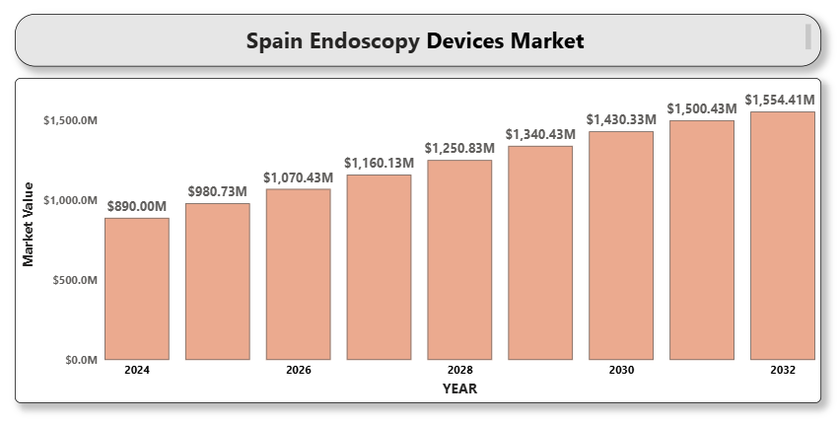

1. **SLOVAKIA ORTHOPEDIC DEVICES MARKET**

**By Product Type (**Joint Reconstruction Devices, Spinal Devices, Trauma Fixation Devices, Orthopedic Braces and Supports, Arthroscopy Devices, Orthobiologics). **By Application (**Hip Orthopedics, Knee Orthopedics, Spine Orthopedics, Craniomaxillofacial Orthopedics, Dental Orthopedics, Sports Injuries, Trauma and Extremities. **By End-User (**Hospitals, Orthopedic Clinics, Ambulatory Surgical Centers (ASCs), Homecare Settings. **By Material (**Metallic Biomaterials, Ceramic Biomaterials, Polymeric Biomaterials, Natural Biomaterials). **By region** (Bratislava Region, Trnava and Trenčín Regions, Nitra and Žilina Regions, Banská Bystrica Region). Global and Regional Industry Overview, Market Intelligence, Comprehensive Analysis, Hystorical Data, and forecastes 2024-2032.

According to Intelli, the Slovakia orthopedic devices market was valued at USD 101.56 million in 2024 and is projected to reach USD 137.49 million by 2032, growing at a CAGR of 4.76% from 2024 to 2032.

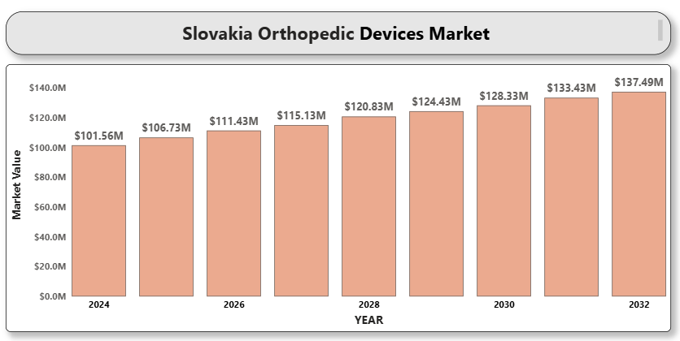

1. **ROMANIA DIAGNOSTIC IMAGING DEVICES MARKET**

**By Product Type (**X-ray Systems, MRI Systems, CT Scanners, Ultrasound Systems, Nuclear Imaging Systems (PET, SPECT), Mammography Systems, Visualization Systems (e.g., monitors and software), Imaging Accessories (e.g., contrast media, imaging plates). **By Application (**Oncology Imaging, Cardiology Imaging, Orthopedic Imaging, Neurological Imaging, Gynecological Imaging, Pediatric Imaging, Other Applications (e.g., trauma, infections)). **By End User (**Hospitals, Ambulatory Surgical Centers, Specialty Clinics, Academic & Research Institutions). **By Region (**Bucharest, Cluj-Napoca, Timisoara, Iasi, Other Regions (e.g., Constanta, Brasov)). Global and Regional Industry Overview, Market Intelligence, Comprehensive Analysis, Hystorical Data, and forecastes 2024-2032.

According to Intelli, the Romania diagnostic imaging devices market was valued at USD 2241 million in 2024 and is projected to reach USD 3128.60 million by 2032, growing at a CAGR of 5.16 % from 2024 to 2032.

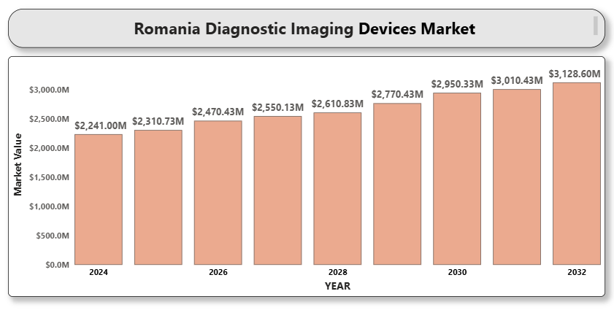

1. **Poland Orthopedic Devices Market**

**By Product** **Type** (**Joint Reconstruction**- Hip Replacement, Knee Replacement, Shoulder Replacement, **Spinal Devices**- Fusion Devices, Non-fusion Devices, **Trauma Fixation Devices**- Plates and Screws, Pins and Wires, **Arthroscopy Devices, Orthobiologics, Others.** B**y End User** (Hospitals, Orthopedic Clinics, Ambulatory Surgical Centers, Rehabilitation Centers). **By Region (**Central Poland, Southern Poland, Northern Poland, Eastern Poland). Global and Regional Industry Overview, Market Intelligence, Comprehensive Analysis, Hystorical Data, and forecastes 2024-2032.

According to Intelli, the Poland orthopedic devices market was valued at USD 420.0 million in 2024 and is projected to reach USD 681.07 million by 2032, growing at a CAGR of 7.13% during the forecast period.

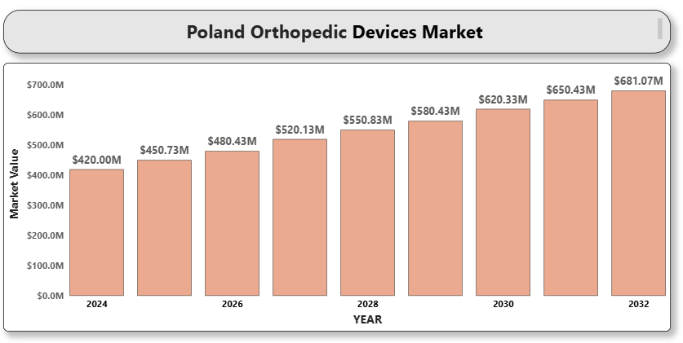

1. **Norway Diagnostic Imaging Devices Market**

**by Product Type (X-ray Imaging Systems**- Digital X-ray, Analog X-ray. **Ultrasound Systems**- 2D Ultrasound, 3D & 4D Ultrasound, Doppler Imaging. **Computed Tomography (CT) Scanners, Magnetic Resonance Imaging (MRI) Systems, Nuclear Imaging Equipment**- PET, SPECT. Mammography Systems, Others. B**y Application (**Cardiology, Oncology, Neurology, Orthopedics, Gynecology, Others). **By End User (**Hospitals, Diagnostic Imaging Centers, Ambulatory Surgical Centers, Clinics. **By Region (**Eastern Norway, Western Norway, Northern Norway, Central Norway). Global and Regional Industry Overview, Market Intelligence, Comprehensive Analysis, Hystorical Data, and forecastes 2024-2032.

According to Intelli, the Norway diagnostic imaging devices market was valued at USD 272.89 million in 2024 and is expected to reach USD 383.03 million by 2032, growing at a CAGR of 5.23% during the forecast period of 2024 to 2032.

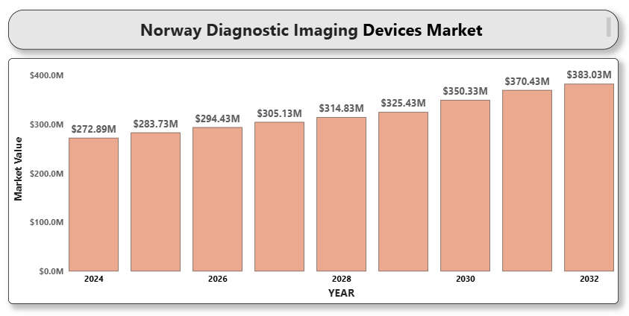

1. **NETHERLANDS MEDICAL DEVICES MARKET**

**By Product Type (**Diagnostic Imaging Devices (MRI, CT, Ultrasound), Therapeutic Devices (Surgical Equipment, Dialysis Machines, Infusion Pumps), Monitoring Devices (ECG, Blood Pressure Monitors, Glucose Monitors), Consumables and Accessories (Syringes, Catheters, Bandages), Wearable and Smart Devices. **By End-User (**Hospitals and Clinics, Home Healthcare, Ambulatory Surgical Centers, Diagnostic Centers. **By Technology (**Conventional Medical Devices, Connected and Digital Devices). **By region** (**North Holland, South Holland, Utrecht, North Brabant, Gelderland, Overijssel, Limburg, Friesland, Drenthe, Zeeland, Groningen, Flevoland**). Global and Regional Industry Overview, Market Intelligence, Comprehensive Analysis, Hystorical Data, and forecastes 2024-2032.

According to Intelli, the Netherlands medical devices market was valued at USD 2137 million in 2024 and is projected to reach USD 5584.91 million by 2032, growing at a CAGR of 13.66% from 2025 to 2032.

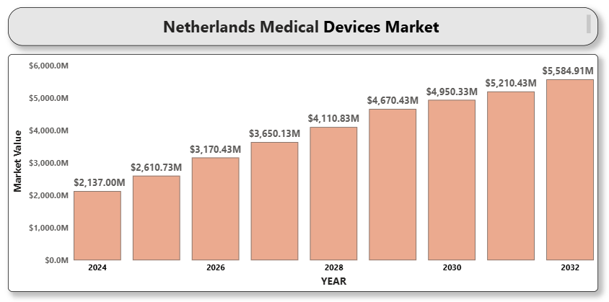

1. **NETHERLANDS DIAGNOSTIC TOOLS MARKET**

**By Product Type** (In-Vitro Diagnostics (IVD), Imaging Diagnostic Tools, Point-of-Care Testing Devices, Molecular Diagnostic Tools, Others (Wearable & AI-Enabled Devices)). **By Application** (Oncology, Cardiology, Infectious Diseases, Diabetes, Others (Genetic Disorders, Autoimmune, etc.). **By End User** (Hospitals & Clinics, Diagnostic Laboratories, Home Care Settings, Academic & Research Institutes. **By region** (**North Holland, South Holland, Utrecht, North Brabant, Gelderland, Overijssel, Limburg, Friesland, Drenthe, Zeeland, Groningen, Flevoland**). Global and Regional Industry Overview, Market Intelligence, Comprehensive Analysis, Hystorical Data, and forecastes 2024-2032.

According to Intelli, the Netherlands Diagnostic Tools Market was valued at USD 2,550 million in 2024 and is projected to reach USD 3505.72 million by 2032, growing at a CAGR of 4.96% during the forecast period of 2024-2032.

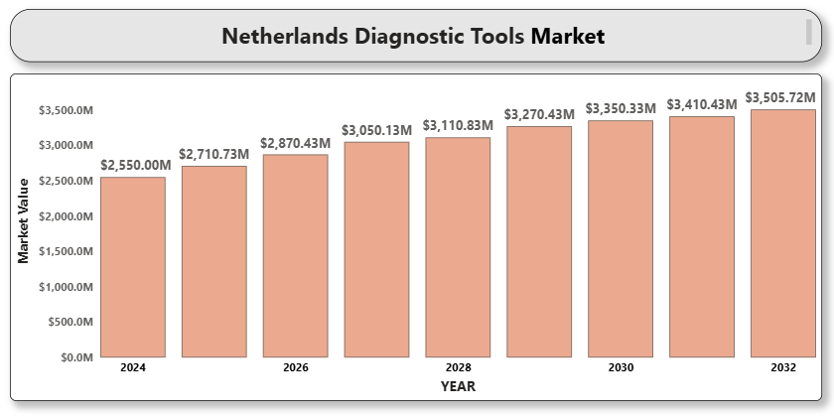

1. **NETHERLANDS DIAGNOSTIC IMAGING DEVICES MARKET**

**By Product Type** (X-ray Imaging Systems, Magnetic Resonance Imaging (MRI), Computed Tomography (CT), Ultrasound Systems, Nuclear Imaging, Mammography. **By End User** (Hospitals & Clinics, Diagnostic Imaging Centers, Ambulatory Surgical Centers (ASCs). **By Portability** (Stationary Devices, Portable Devices). **By region** (**North Holland, South Holland, Utrecht, North Brabant, Gelderland, Overijssel, Limburg, Friesland, Drenthe, Zeeland, Groningen, Flevoland**). Global and Regional Industry Overview, Market Intelligence, Comprehensive Analysis, Hystorical Data, and forecastes 2024-2032.

According to Intelli, the Netherlands diagnostic imaging devices market was valued at USD 1,250 million in 2024 and is projected to reach USD 1791.14 million by 2032, growing at a CAGR of 5.5% from 2025 to 2032.

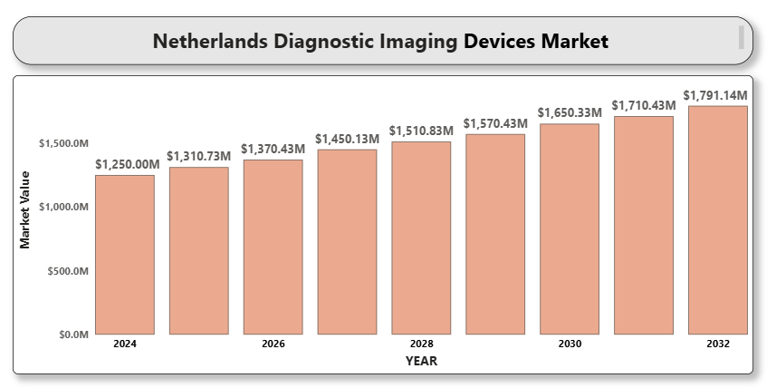

1. **Netherlands Diabetes Care Devices Market**

**By Product Type** (Blood Glucose Meters, Continuous Glucose Monitors (CGM), Insulin Delivery Devices (Pumps, Pens, and Syringes), Other Accessories (Test Strips, Lancets, etc.). **Market Segmentation by End-User** (Hospitals, Clinics, Home Care Settings). **Market Segmentation by Technology** (Traditional Blood Glucose Meters, Smart/Connected Blood Glucose Meters, Continuous Glucose Monitoring Systems (CGM), Wearable Insulin Delivery Devices. **Market Segmentation by Application** (Type 1 Diabetes, Type 2 Diabetes). **By region** (**North Holland, South Holland, Utrecht, North Brabant, Gelderland, Overijssel, Limburg, Friesland, Drenthe, Zeeland, Groningen, Flevoland**). Global and Regional Industry Overview, Market Intelligence, Comprehensive Analysis, Hystorical Data, and forecastes 2024-2032.

According to Intelli, the Netherlands diabetes care devices market was valued at USD 1,016.67 million in 2024 and is projected to reach USD 2025.64 million by 2032, growing at a CAGR of 9.9% from 2024 to 2032.

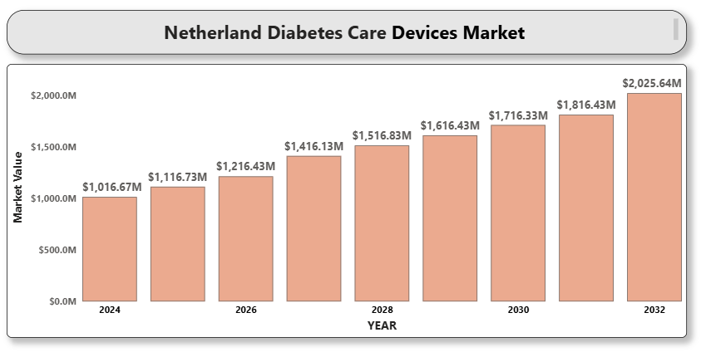

1. **MALTA MEDICAL DEVICES MARKET**

**By Device Type** (Diagnostic Imaging Devices, Therapeutic Devices, Surgical Devices, Patient Monitoring Devices, Orthopedic Devices, Consumables & Disposables). **By End User** (Hospitals and Clinics, Ambulatory Surgical Centers, Diagnostic Centers, Home Healthcare**. By region** (Northern Region, Southern Region, Central Region, South Eastern Region, Western Region, Gozo and Comino Region). Global and Regional Industry Overview, Market Intelligence, Comprehensive Analysis, Hystorical Data, and forecastes 2024-2032.

According to Intelli, the Malta medical devices market was valued at USD 100.05 million in 2024 and is projected to reach USD 109.19w million by 2032, growing at a CAGR of 1.45% during the forecast period.

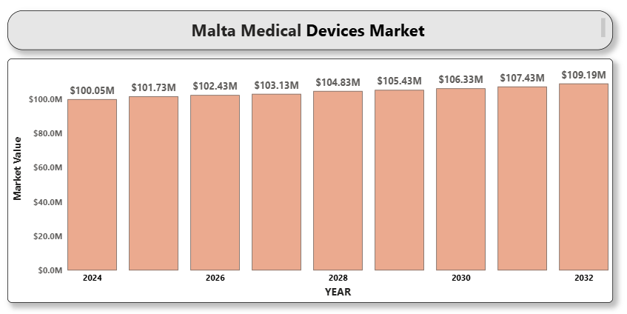

1. **MACEDONIA ENDOSCOPY DEVICES MARKET**

**By Product Type** (Endoscopes, Visualization Systems, Operative Devices, Other Accessories). B**y End-User** (Hospitals, Ambulatory Surgical Centers (ASCs), Specialty Clinics. B**y Technology** (Flexible Endoscopes, Rigid Endoscopes, Capsule Endoscopy. **By Application** (Gastrointestinal (GI) Endoscopy, Laparoscopy, Obstetrics/Gynecology Endoscopy, Arthroscopy, Bronchoscopy, Other Applications). **By region** (Skopje, Polog, Pelagonia, Vardar, Eastern, Northeastern, Southeastern, Southwestern). Global and Regional Industry Overview, Market Intelligence, Comprehensive Analysis, Hystorical Data, and forecastes 2024-2032.

According to Intelli, the Macedonia endoscopy devices market was valued at USD 7 million in 2024 and is projected to reach USD 13.5 million by 2032, growing at a CAGR of 9% from 2024 to 2032.

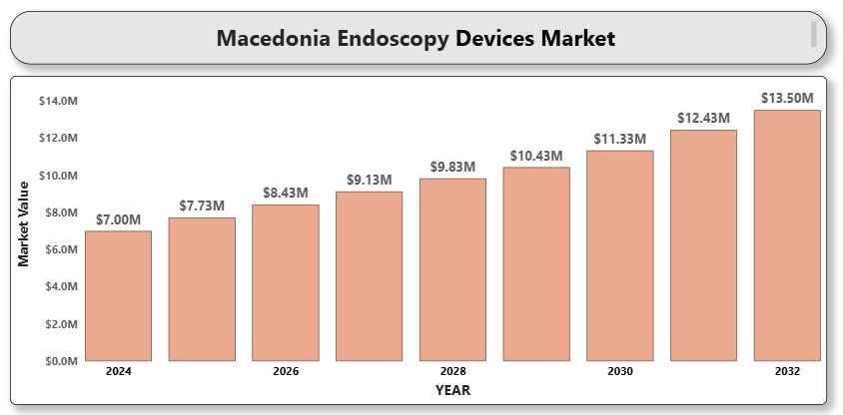

1. **LITHUANIA ENDOSCOPY DEVICES MARKET**

**By Product Type** (Endoscopes (Flexible, Rigid, Capsule), Visualization Systems (Cameras, Displays, Light Sources, Recorders), Operative Devices (Biopsy Forceps, Graspers, Snares, Scissors), Insufflators, Accessories (Trocars, Cleaning Brushes, Tubing Sets). **By Application** (Gastrointestinal Endoscopy, Laparoscopy, Bronchoscopy, Urology Endoscopy, Gynecology Endoscopy, Arthroscopy, Others (ENT, Neurology). **By End User** (Hospitals and Clinics, Ambulatory Surgical Centers (ASCs), Diagnostic Centers. By region (Vilnius, Kaunas, Klaipėda, Šiauliai, Panevėžys, Alytus, Marijampolė, Telšiai, Tauragė, Utena). Global and Regional Industry Overview, Market Intelligence, Comprehensive Analysis, Hystorical Data, and forecastes 2024-2032.

According to Intelli, the Lithuania endoscopy devices market was valued at USD 74.8 million in 2024 and is projected to reach USD 109.3 million by 2032, growing at a CAGR of 4.8% from 2025 to 2032.

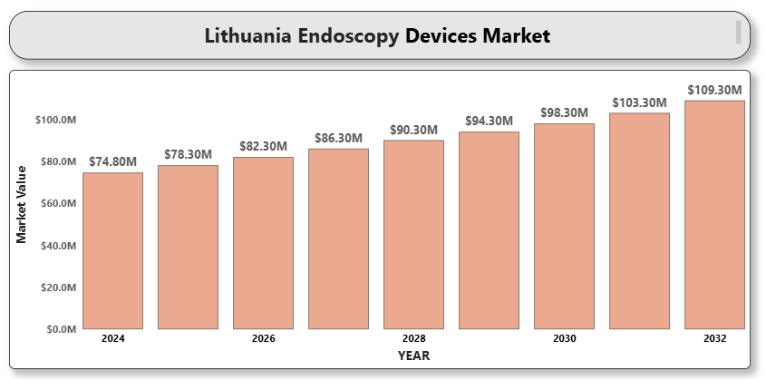

1. **LIECHTENSTEIN PERSONALIZED MEDICINE DEVICES MARKET**

**By Product Type** (Companion Diagnostics, Genomic Sequencing Devices, Wearable Health Monitors, Point-of-Care Testing Devices, Digital Therapeutic Devices, AI-Based Predictive Tools). **By Application** (Oncology, Cardiology, Neurology, Infectious Diseases, Rare & Genetic Disorders, Preventive Health Monitoring). **By End Use** (Hospitals & Clinics, Research Institutes, Diagnostic Laboratories, Homecare Settings, Academic & Genomic Research Centers). **By region** (Vaduz, Schaan, Balzers, Triesen, Eschen, Mauren, Triesenberg, Ruggell, Gamprin, Schellenberg, Planken). Global and Regional Industry Overview, Market Intelligence, Comprehensive Analysis, Hystorical Data, and forecastes 2024-2032.

According to Intelli, the Liechtenstein personalized medicine devices market was valued at USD 9.8 million in 2024 and is projected to reach USD 18.4 million by 2032, growing at a CAGR of 8.2% during the forecast period.

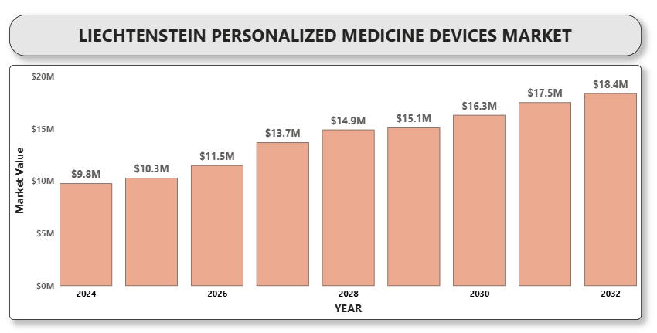

1. **LIECHTENSTEIN ORTHOPEDIC DEVICES MARKET**

**By Product Type** (Joint Reconstruction Devices, Spinal Devices, Trauma Fixation Devices, Arthroscopic Devices, Orthobiologics). **By End User** (Hospitals, Orthopedic Clinics, Ambulatory Surgical Centers, Homecare Settings). **By Technology** (Conventional Devices, Minimally Invasive Surgery Devices, Robotic-Assisted Devices, 3D-Printed Orthopedic Implants). **By Application** (Joint Reconstruction, Spinal Disorders, Sports Injuries, Trauma Cases, Other Applications. **By region** (Vaduz, Schaan, Balzers, Triesen, Eschen, Mauren, Triesenberg, Ruggell, Gamprin, Schellenberg, Planken). Global and Regional Industry Overview, Market Intelligence, Comprehensive Analysis, Hystorical Data, and forecastes 2024-2032.

According to Intelli, the Liechtenstein orthopedic devices market was valued at USD 3.13 million in 2024 and is projected to reach USD 4.73 million by 2032, growing at a CAGR of 5.17% from 2024 to 2032.

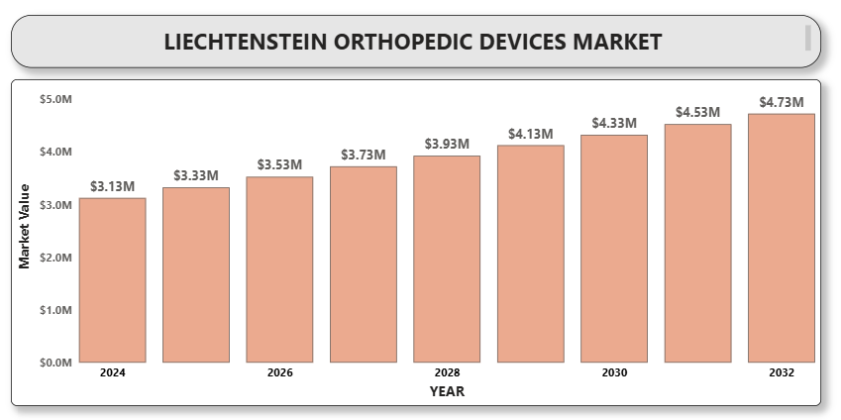

1. **Italy Respiratory Devices Market**

**by Product Type** (Therapeutic Devices, Monitoring Devices, Diagnostic Devices, Consumables & Accessories. B**y End-User** (Hospitals, Home Healthcare, Ambulatory Surgical Centers (ASCs) and Clinics). **By Technology** (Invasive Respiratory Devices, Non-Invasive Respiratory Devices. **By Application** (COPD, AsthmaSleep Apnea, Other Applications). **By region** (Lombardy, Lazio, Campania, Veneto, Emilia-Romagna, Piedmont, Tuscany, Sicily, Apulia, Calabria, Sardinia, Liguria, Marche, Abruzzo, Friuli Venezia Giulia, Trentino-Alto Adige/Südtirol, Umbria, Basilicata, Molise, Aosta Valley). Global and Regional Industry Overview, Market Intelligence, Comprehensive Analysis, Hystorical Data, and forecastes 2024-2032.

According to Intelli, the Italy respiratory devices market was valued at USD 1,269 million in 2024 and is projected to reach USD 1932.65 million by 2032, growing at a CAGR of 6.30% from 2024 to 2032.

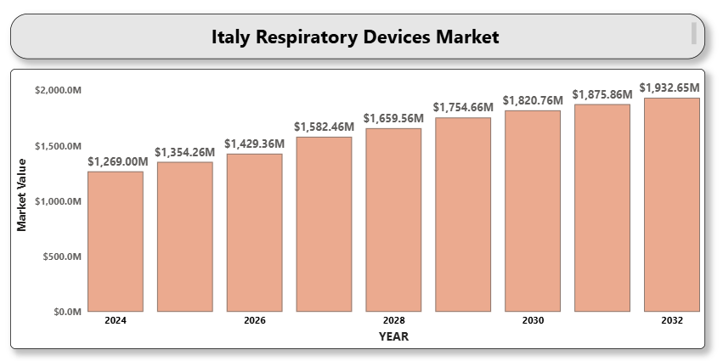

1. **ITALY INTERVENTIONAL CARDIOLOGY DEVICES MARKET**

**By Product Type (**Coronary Stents (DES, BMS, Bioresorbable), Catheters (Balloon, Guiding, Diagnostic), Guidewires, Intravascular Ultrasound (IVUS), Fractional Flow Reserve (FFR) Devices, Atherectomy Devices, Others). **By End-User (**Hospitals, Cardiac Centers, Ambulatory Surgical Centers (ASCs)**,** Research & Academic Institutions). B**y Application (**Coronary Artery Disease, Valvular Heart Disease, Congenital Heart Defects, Others). **By region** (Lombardy, Lazio, Campania, Veneto, Emilia-Romagna, Piedmont, Tuscany, Sicily, Apulia, Calabria, Sardinia, Liguria, Marche, Abruzzo, Friuli Venezia Giulia, Trentino-Alto Adige/Südtirol, Umbria, Basilicata, Molise, Aosta Valley). Global and Regional Industry Overview, Market Intelligence, Comprehensive Analysis, Hystorical Data, and forecastes 2024-2032.

According to Intelli, the Italy interventional cardiology devices market was valued at USD 15,567.13 million in 2024 and is projected to reach 24463.51 at a CAGR of 7.5% from 2024 to 2032.

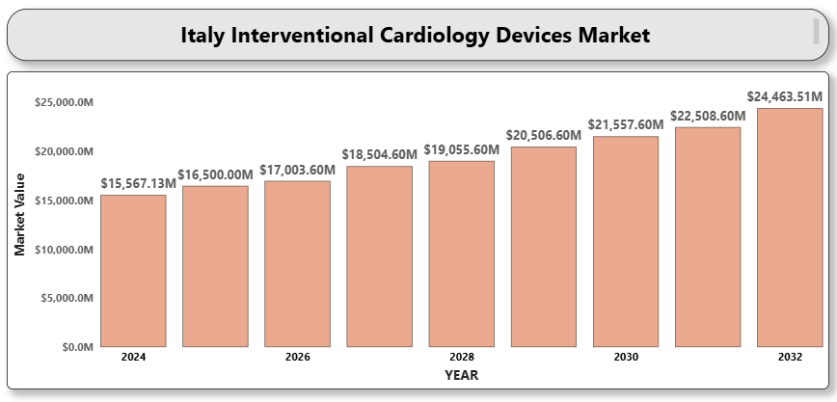

1. **ITALY DIAGNOSTIC CENTERS MARKET**

**By Service Type** (Imaging Services, Pathology Services, Cardiology Diagnostics, Genetic Testing, Others). **By End User** (Hospitals, Standalone Diagnostic CentersClinics and Physician Offices, Home Healthcare Providers). **By region** (Lombardy, Lazio, Campania, Veneto, Emilia-Romagna, Piedmont, Tuscany, Sicily, Apulia, Calabria, Sardinia, Liguria, Marche, Abruzzo, Friuli Venezia Giulia, Trentino-Alto Adige/Südtirol, Umbria, Basilicata, Molise, Aosta Valley). Global and Regional Industry Overview, Market Intelligence, Comprehensive Analysis, Hystorical Data, and forecastes 2024-2032.

According to Intelli, the Italy diagnostic centers market was valued at USD 1,441.83 million in 2024 and is projected to reach USD 2113.90 million by 2032, growing at a CAGR of 5.80% over the forecast period of 2024-2032.

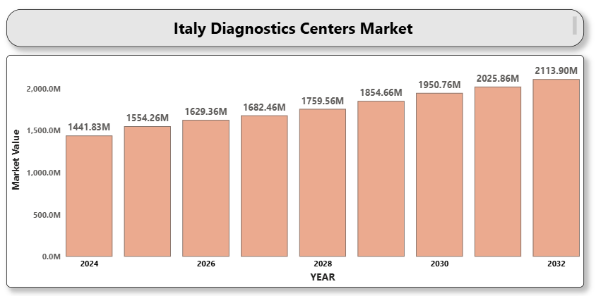

1. **ITALY DIABETES CARE DEVICES MARKET**

**By Product Type**(**Blood Glucose Monitoring Devices**: Includes blood glucose meters, test strips, and lancets. **Continuous Glucose Monitoring (CGM) Systems**: Includes sensors, transmitters, and receivers. Insulin Delivery Devices: Includes insulin pens, insulin pumps, and jet injectors. Others: Includes diabetes management apps, smart insulin patches, and implantable sensors). **By End User (**Hospitals & Clinics: Primary healthcare providers for diabetes diagnosis and treatment. Homecare Settings: Rising due to remote monitoring, telemedicine, and personalized diabetes care. Diagnostic Centers: Specialized in diabetes screening and long-term glucose tracking). **By Distribution Channel (**Retail Pharmacies: Widely accessible point of purchase for diabetes care products. Online Pharmacies: Rapidly growing due to convenience, discounts, and digital health integration. Hospital Pharmacies: Serve inpatient and outpatient diabetes management needs). **By region** (Lombardy, Lazio, Campania, Veneto, Emilia-Romagna, Piedmont, Tuscany, Sicily, Apulia, Calabria, Sardinia, Liguria, Marche, Abruzzo, Friuli Venezia Giulia, Trentino-Alto Adige/Südtirol, Umbria, Basilicata, Molise, Aosta Valley). Global and Regional Industry Overview, Market Intelligence, Comprehensive Analysis, Hystorical Data, and forecastes 2024-2032.

According to Intelli, the Italy diabetes care devices market was valued at USD 1,193.3 million in 2024 and is projected to reach USD 1919.09 million by 2032, growing at a CAGR of 7.02% from 2024 to 2032.

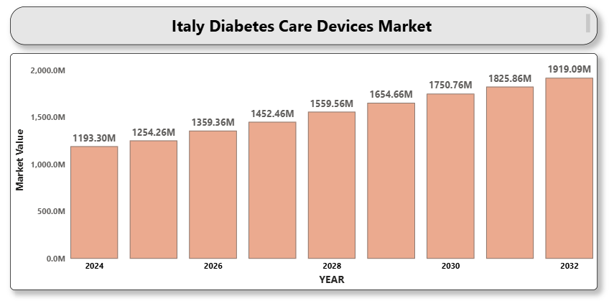

1. **IRELAND DIABETES CARE DEVICES MARKET**

**By Product Type (**Blood Glucose Monitoring Devices, Continuous Glucose Monitoring (CGM) Systems, Insulin Delivery Devices, Others). B**y End-User (**Hospitals & Clinics, Homecare Settings, Diagnostic Centers. **By Application (**Type 1 Diabetes, Type 2 Diabetes, Gestational Diabetes). **By region** (Leinster, Munster, Connacht, Ulster (Republic of Ireland only). Global and Regional Industry Overview, Market Intelligence, Comprehensive Analysis, Hystorical Data, and forecastes 2024-2032.

According to Intelli, the Ireland Diabetes Care Devices Market was valued at USD 117.54 million in 2024 and is projected to reach USD 211.65 million by 2032, growing at a CAGR of 8.53% from 2024 to 2032.

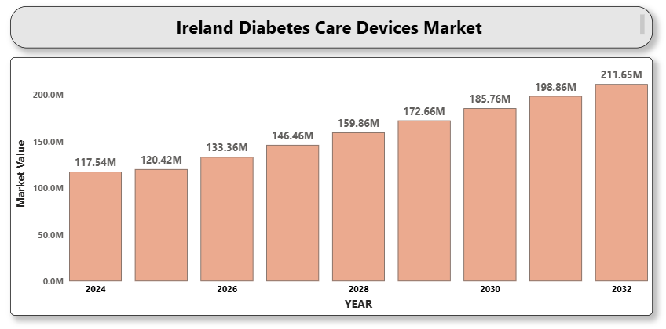

1. **ICELAND MEDICAL DEVICES MARKET**

**By ProductType** (Diagnostic Imaging Devices, Therapeutic Devices, Surgical Devices, Monitoring Devices, Consumables & Disposables, Digital Health Solutions). **By End Use** (Hospitals, Ambulatory Surgical Centers, Diagnostic Centers, Home Healthcare, Specialty Clinics). By region (Capital Region, Southern Peninsula (Reykjanes), West, Westfjords, Northwest, Northeast, East, South). Global and Regional Industry Overview, Market Intelligence, Comprehensive Analysis, Hystorical Data, and forecastes 2024-2032.

According to Intelli, the Iceland medical devices market was valued at USD 95.71 million in 2024 and is projected to reach USD 170.68 million by 2032, growing at a CAGR of 8.4% during the forecast period.

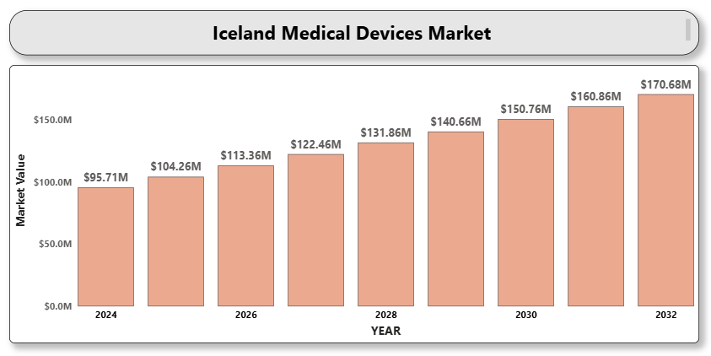

1. **Hungary ophthalmic devices market**

**By Product Type (Diagnostic Devices**– (Optical Coherence Tomography (OCT), Fundus Cameras, Ophthalmoscopes, Autorefractors and Keratometers, Tonometers). **Surgical Devices**– (Cataract Surgery Devices, Glaucoma Surgery Devices, Vitreoretinal Surgery Devices, Refractive Surgery Devices). **Vision Care Devices**– (Spectacles, Contact Lenses). B**y Application (**Cataract, Glaucoma, Refractive Error, Age-related Macular Degeneration, Diabetic Retinopathy, Others). B**y End User (**Hospitals, Ophthalmic Clinics, Ambulatory Surgical Centers, Others. B**y Region**(Central Hungary, Transdanubia, Northern Hungary). Global and Regional Industry Overview, Market Intelligence, Comprehensive Analysis, Hystorical Data, and forecastes 2024-2032.

According to Intelli, the Hungary ophthalmic devices market was valued at USD 56.88 million in 2024 and is expected to reach USD 77.26 million by 2032, growing at a CAGR of 4.29% from 2024 to 2032.

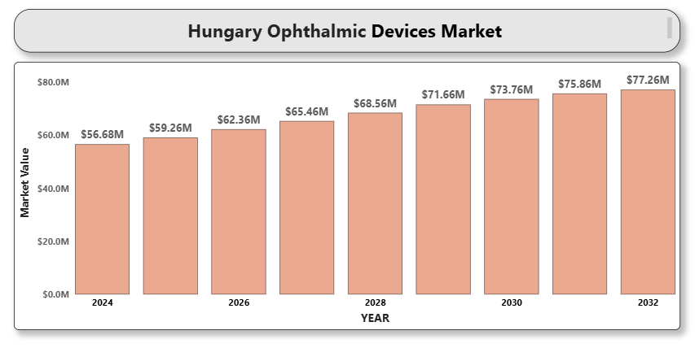

1. **GREECE CARDIOLOGY DEVICES MARKET**

**By Product Type (**Diagnostic and Monitoring Devices-ECG Devices, Holter Monitors, Event Monitors, Implantable Loop Recorders. Therapeutic and Surgical Devices-Pacemakers, Defibrillators, Stents, Heart Valves, Others). **By End-User (**Hospitals and Clinics, Ambulatory Surgical Centers, Homecare Settings). B**y Application (**Coronary Artery Disease, Heart Failure, Cardiac Arrhythmias, Others). **By region (**Northern Greece, Central Greece, Attica, Aegean Islands, Crete, Peloponnese, Thessaly, Epirus, Macedonia-Thrace, Western Greece, Ionian Islands). Global and Regional Industry Overview, Market Intelligence, Comprehensive Analysis, Hystorical Data, and forecastes 2024-2032.

According to Intelli, the Greece Cardiology Devices Market was valued at USD 9,949.13 million in 2024 and is projected to reach USD 14234.46 million by 2032, growing at a CAGR of 5.48% from 2024 to 2032.

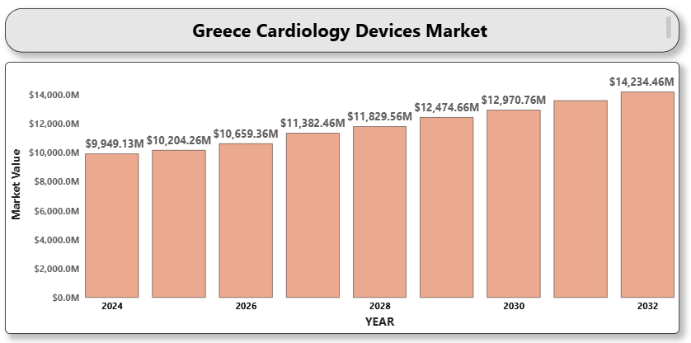

1. **Germany Smart Medical Devices Market**

**By Product Type (Diagnostics & Monitoring Devices, Therapeutic Devices**). **By Type (**On-body (Adhesive Patch)**,** Off-body (Belt Clip)**,** Handheld Devices. **By Technology (**Spring-based**,** Motor-driven**,** Rotatory Pump**,** Expanding Battery**,** Pressurized Gas**,** Others​**). By Modality (Wearable Devices, Non-wearable Devices**). **By Application (**Oncology**,** Diabetes Management**,** Autoimmune Disorders**,** Infectious Diseases**,** Sports and Fitness**,** Sleep Disorders**,** Others​**). By End User (**Hospitals**,** Clinics**,** Home Care Settings**,** Sports Clubs**,** Others​). **By Distribution Channel (**Pharmacies**,** Online Channels**,** Others). Global and Regional Industry Overview, Market Intelligence, Comprehensive Analysis, Hystorical Data, and forecastes 2024-2032.

According to Scholavar, the Germany Smart Medical Devices Market was valued at approximately USD 11,646.60 million in 2024 and is projected to reach USD 31179.67 million,  growing at a compound annual growth rate (CAGR) of 14% during the forecast period of 2024 to 2032.

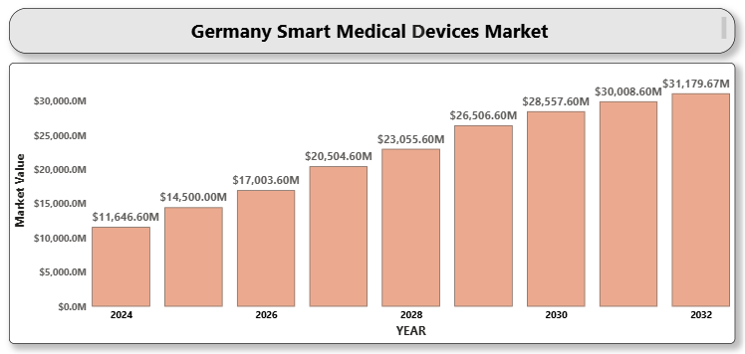

1. **Germany Respiratory Devices Market**

**By Product Type (Therapeutic Devices: Inhalers, Nebulizers, Oxygen Concentrators, Ventilators , CPAP & BiPAP Devices, Humidifiers.​ Diagnostic & Monitoring Devices: Spirometers, Pulse Oximeters, Sleep Test Devices. Peak Flow Meters. Disposables: Masks, Breathing Circuits ).** **By Application ( Chronic Obstructive Pulmonary Disease (COPD) , Asthma, Sleep Apnea, Infectious Respiratory Diseases, Others). By End-User (Hospitals, Home Care Settings, Ambulatory Surgical Centers (ASCs) & Specialty Clinics).** **By Region (Urban Centers (Berlin, Munich, Hamburg), Rural Areas, Western and Southern Germany).** Global and Regional Industry Overview, Market Intelligence, Comprehensive Analysis, Hystorical Data, and forecastes 2024-2032.

According to Intelli, the Germany Respiratory Devices Market was valued at approximately USD 4,870 million in 2024 and is projected to reach USD 7530.21 million, growing at a compound annual growth rate (CAGR) of 6.50% during the forecast period (2024-2032).

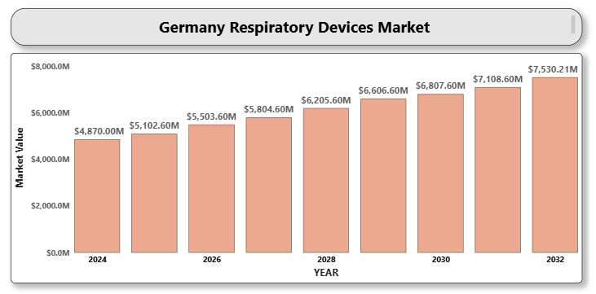

# GERMANY MEDICAL TECHNOLOGY MARKET

**By Product Type** ( Diagnostic Imaging Devices, Patient Monitoring Devices, Surgical Devices, Respiratory Devices, Orthopedic Devices, Home Healthcare DevicesWearable Health Tech, Digital Therapeutics). **By End User** ( Hospitals, Diagnostic Centers, Ambulatory Surgical Centers (ASCs), Homecare Settings, Specialty Clinics). By Technology (Robotics, Artificial Intelligence, Internet of Medical Things (IoMT), 3D Printing, Wearables). **By Application** (Cardiology, Orthopedics, Respiratory, Neurology, Oncology, Gynecology, Others)**. By Region (Urban Centers (Berlin, Munich, Hamburg), Rural Areas, Western and Southern Germany).** Global and Regional Industry Overview, Market Intelligence, Comprehensive Analysis, Hystorical Data, and forecastes 2024-2032.

According to Intelli, the Germany medical technology market was valued at USD 46,100 million in 2024 and is projected to reach USD 64556.78 million by 2032, growing at a CAGR of 5.2% from 2025 to 2032.

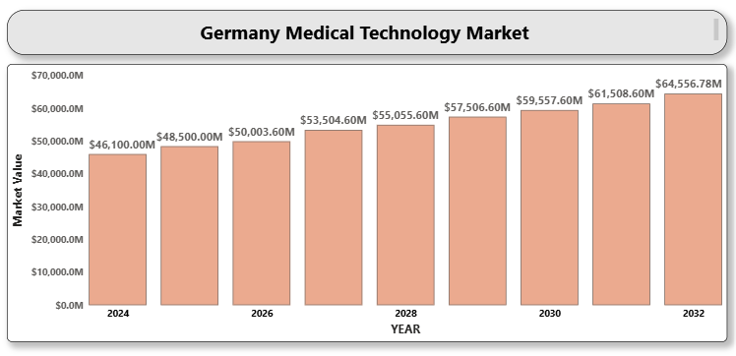

1. **GERMANY HEALTHCARE SERVICE CENTERS MARKET**

**By Service Type** (**Diagnostic Imaging Services**-Dialysis Centers, Ambulatory Surgical Centers, Rehabilitation and Physiotherapy Centers, Primary and Specialty Clinics, Others (Urgent Care, Preventive Health). **By End User** (Public Healthcare Facilities, Private Healthcare Providers, Health Insurance Organizations, Others (Employers, NGOs)). **By Region (Urban Centers (Berlin, Munich, Hamburg), Rural Areas, Western and Southern Germany).** Global and Regional Industry Overview, Market Intelligence, Comprehensive Analysis, Hystorical Data, and forecastes 2024-2032.

According to Intelli, the Germany healthcare service centers market was valued at USD 43,333.33 million in 2024 and is expected to reach USD 56311.79 million by 2032, growing at a CAGR of 5.23% during the forecast period of 2024-2032.

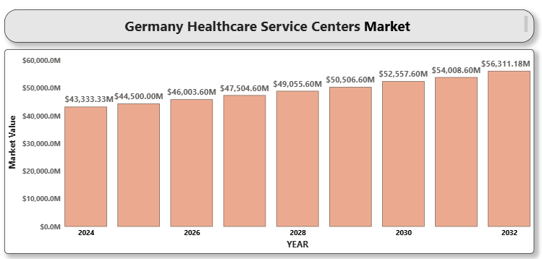

1. **Germany Cardiovascular Devices Market**

**By Product Type( Diagnostic and Monitoring Devices-**Electrocardiogram (ECG)**,** Remote Cardiac Monitoring**,** Other Diagnostic and Monitoring Devices**. Therapeutic and Surgical Devices-**Cardiac Assist Devices, Cardiac Rhythm Management Devices**,** Catheters**,** Grafts**,** Heart Valves**,** Stents**,** Other Therapeutic and Surgical Devices**). By Application (**Coronary Artery Disease**,** Arrhythmia**,** Heart Failure**,** Peripheral Artery Disease**,**  Cardiomyopathy**,** Congenital Heart Defects). **By End-User (**Hospitals and Cardiac Centers, Ambulatory Surgical Centers (ASCs)**,** Diagnostic Centers**,** Home Care Settings). **By Technology (**Invasive Devices, Non-Invasive Devices**,** Minimally Invasive Devices**). By Region (**Munich**,** Berlin). Global and Regional Industry Overview, Market Intelligence, Comprehensive Analysis, Hystorical Data, and forecastes 2024-2032.

According to Scholavar, the Germany Cardiovascular Devices Market was valued at approximately USD 5,240 million in 2024 and is projected to reach USD 7366.10 million, growing at a compound annual growth rate (CAGR) of 5.25% during the forecast period (2024-2032).

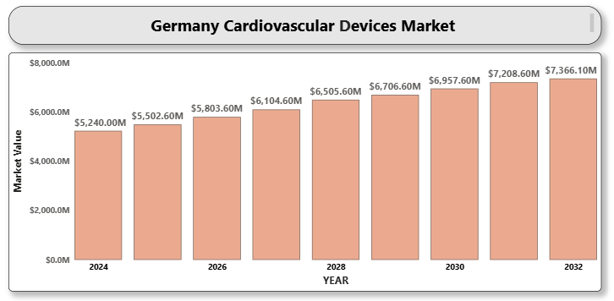

1. **GERMANY BIOPHARMACEUTICAL MARKET**

**By Product Type (**Monoclonal Antibodies (mAbs), Vaccine, Recombinant Proteins, Gene Therapy Products, Cell Therapy Products, Biosimilars, Others). **By Therapeutic Application (**Oncology, Autoimmune Diseases, Infectious Diseases, Cardiovascular Disorders, Metabolic Disorders, Neurological Disorders, Other Applications). B**y End-User (**Hospitals and Clinics, Research & Academic Institutes, Biopharmaceutical Companies, Others. **By Region (**Munich**,** Berlin). Global and Regional Industry Overview, Market Intelligence, Comprehensive Analysis, Hystorical Data, and forecastes 2024-2032.

According to Intelli, the Germany Biopharmaceutical Market was valued at USD 149,250 million in 2024 and is projected to reach USD 291526.87 million by 2032, growing at a CAGR of 9.63% from 2025 to 2032.

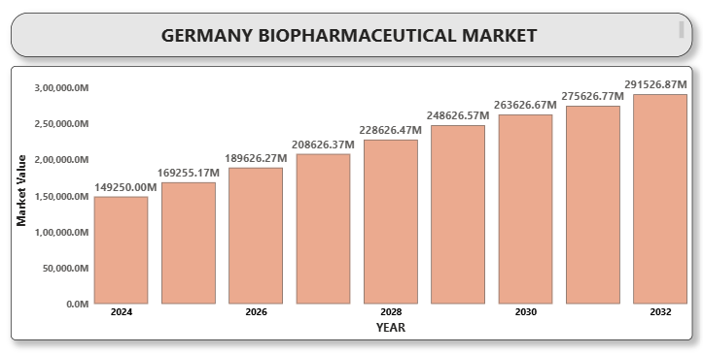

1. **FRENCH DENTAL MEDICAL DEVICES MARKET**

**By Product Type (**Diagnostic Dental Equipment (e.g., X-ray systems, intraoral scanners), Therapeutic Dental Equipment (e.g., dental lasers, chairs, delivery units), Prosthetics & Restoratives (e.g., crowns, bridges, dentures), Orthodontic Devices (e.g., braces, aligners), Dental Consumables (e.g., adhesives, sealants, impression materials). **By End-User (**Dental Clinics, Hospitals, Academic & Research Institutes, Dental Laboratories). **By Technology (**Conventional Devices, Digital Dentistry (CAD/CAM, AI, 3D Printing). **By Region (**Paris, Lyon, Marseille, Toulouse, Others). Global and Regional Industry Overview, Market Intelligence, Comprehensive Analysis, Hystorical Data, and forecastes 2024-2032.

According to Intelli, the French dental medical devices market was valued at USD 462 million in 2024 and is projected to reach USD 719.80 million by 2032, growing at a CAGR of 6.6% from 2025 to 2032.

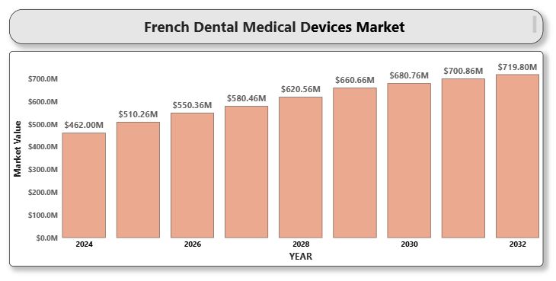

1. **France Respiratory Devices Market**

**By Product Type** (Oxygen Concentrators, Nebulizers, CPAP Devices, Ventilators, Others). **By Application** (Chronic Obstructive Pulmonary Disease (COPD), Sleep Apnea, Asthma, Other Respiratory Disorders). **By End-user (**Hospitals, Homecare Settings, Specialty Clinics. **By Region (**Paris, Lyon, Marseille, Toulouse, Others). Global and Regional Industry Overview, Market Intelligence, Comprehensive Analysis, Hystorical Data, and forecastes 2024-2032.

According to Intelli, the France Respiratory Devices Market size was valued at approximately USD 1,600 million in 2024 and is projected to reach USD 2327.968 million at a compound annual growth rate (CAGR) of 5.7 % over the forecast period from 2024 to 2032.

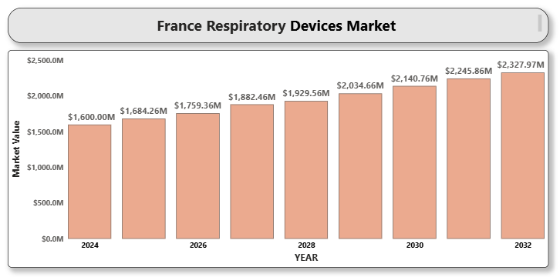

1. **FRANCE OPHTHALMIC DEVICES MARKET**

**By Product Type** (Diagnostic Devices, Surgical Devices, Vision Care Devices, Therapeutic Devices). **By End User** (Hospitals, Ophthalmic Clinics, Ambulatory Surgical Centers (ASCs), Homecare Settings). **By Technology** (Optical Coherence Tomography (OCT), Laser Technology, Ultrasound Imaging, Wearable Technologies). **By Application** (Cataract Surgery, Refractive Error Correction, Glaucoma Surgery, Retinal Disorder, Others. **By End-user (**Hospitals, Homecare Settings, Specialty Clinics. **By Region (**Paris, Lyon, Marseille, Toulouse, Others). Global and Regional Industry Overview, Market Intelligence, Comprehensive Analysis, Hystorical Data, and forecastes 2024-2032.

According to Intelli, the France ophthalmic devices market was valued at USD 1,173.9 million in 2024 and is projected to reach USD 1696.30 million by 2032, growing at a CAGR of 5.61% from 2024 to 2032.

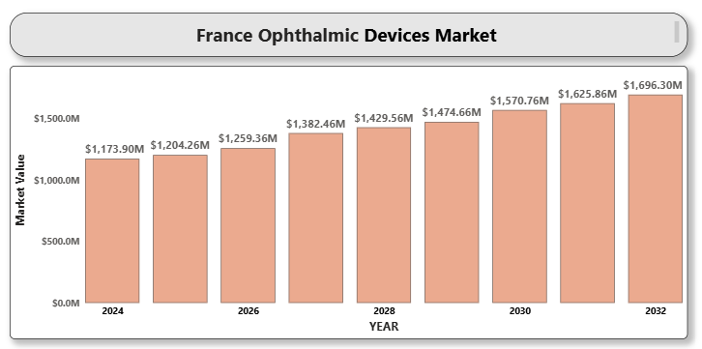

1. **FRANCE ENDOSCOPY DEVICES MARKET**

**By Product Type** (Endoscopes, Visualization Systems, Operative Devices, Other Accessories). B**y End-User** (Hospitals, Ambulatory Surgical Centers (ASCs), Specialty Clinics). **By Technology** (Flexible Endoscopes, Rigid Endoscopes, Capsule Endoscopy). B**y Application** (Gastrointestinal (GI) Endoscopy, Laparoscopy, Obstetrics/Gynecology Endoscopy, Arthroscopy, Bronchoscopy, Other Applications). **By Region (**Paris, Lyon, Marseille, Toulouse, Others). Global and Regional Industry Overview, Market Intelligence, Comprehensive Analysis, Hystorical Data, and forecastes 2024-2032.

According to Intelli, the France endoscopy devices market was valued at USD 2,203.3 million in 2024 and is projected to reach USD 3335.24 million by 2032, growing at a CAGR of 6.22% from 2024 to 2032.

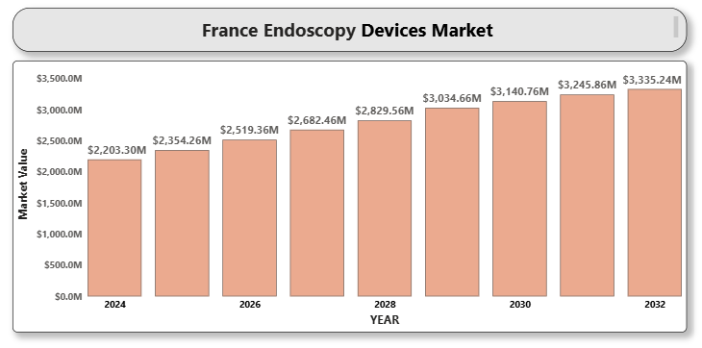

1. **FRANCE DIAGNOSTIC IMAGING DEVICES MARKET**

**By Product Type** (MRI Systems, CT Scanners, Ultrasound Systems, X-ray Systems, Nuclear Medicine Imaging Systems, Other Diagnostic Imaging Devices). **By End-User** (Hospitals, Diagnostic Imaging Centers, Ambulatory Surgical Centers (ASCs), Research and Academic Institutes). B**y Technology** (Artificial Intelligence (AI)-Enhanced Imaging, 3D Imaging, Portable Imaging Devices, Digital Imaging). **By Application** (Cardiovascular Imaging, Neurological Imaging, Musculoskeletal Imaging, Oncology Imaging, Other Applications). **By Region (**Paris, Lyon, Marseille, Toulouse, Others). Global and Regional Industry Overview, Market Intelligence, Comprehensive Analysis, Hystorical Data, and forecastes 2024-2032.

According to Intelli, the France diagnostic imaging devices market was valued at USD 1,118.17 million in 2024 and is projected to reach USD 1682.37 million by 2032, growing at a CAGR of 6.14% from 2024 to 2032.

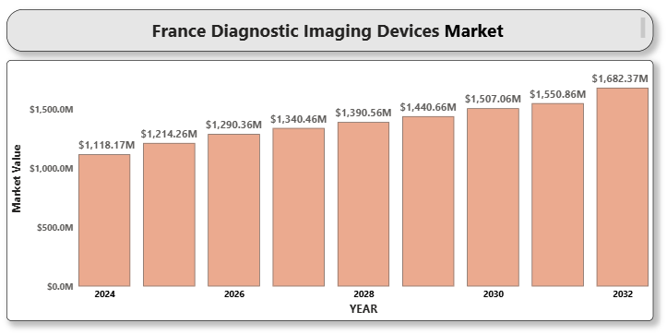

1. **FRANCE DIABETES CARE DEVICES MARKET**

**By Product** **Type** (Self-Monitoring Devices, Continuous Glucose Monitoring (CGM) Devices, Insulin Pumps • Insulin Pens, Insulin Syringes, Others). **By End-User (**Hospitals, Homecare Settings, Clinics and Diagnostic Centers, Others). **By** **Region (**Northern France, Central France, Southern France). Global and Regional Industry Overview, Market Intelligence, Comprehensive Analysis, Hystorical Data, and forecastes 2024-2032.

According to Intelli, the France diabetes care devices market was valued at USD 1,285.7 million in 2024 and is projected to reach USD 2111.74 million by 2032, growing at a CAGR of 7.3% from 2024 to 2032.

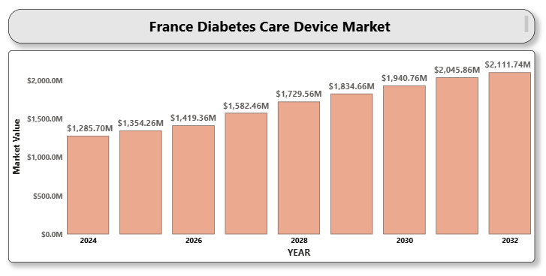

1. **FRANCE CARDIOLOGY DEVICES MARKET**

**By Product Type (**Diagnostic and Monitoring Devices, Therapeutic and Surgical Devices, Cardiac Rhythm Management Devices). B**y End-User (**Hospitals, Cardiac Centers, Ambulatory Surgical Centers (ASCs), Homecare Settings). B**y Technology (**Invasive Devices, Non-Invasive Devices). B**y Application (**Coronary Artery Disease, Cardiac Arrhythmia, Heart Failure, Congenital Heart Disease, Other Applications). **By** **Region (**Northern France, Central France, Southern France). Global and Regional Industry Overview, Market Intelligence, Comprehensive Analysis, Hystorical Data, and forecastes 2024-2032.

According to Intelli, the France cardiology devices market was valued at USD 1931.96 million in 2024 and is projected to reach USD 3007.71 million by 2032, growing at a CAGR of 6.59% from 2024 to 2032.

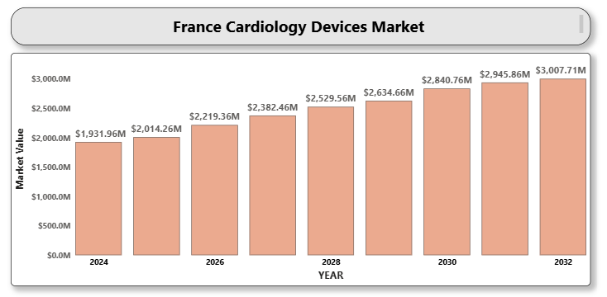

1. **FRANCE AI IN HEALTHCARE MARKET**

**By Component** (Software, Hardware, Services). **By Application** (Medical Imaging & Diagnostics, Virtual Assistants, Robot-Assisted Surgery, Drug Discovery, Administrative Workflow Assistance). By **End Use (**Hospitals & Healthcare Providers, Pharmaceutical & Biotechnology Companies, Patients, Others (Research Institutes, Academic Institutions). **By** **Region (**Northern France, Central France, Southern France). Global and Regional Industry Overview, Market Intelligence, Comprehensive Analysis, Hystorical Data, and forecastes 2024-2032.

According to Intelli, the France AI in Healthcare market was valued at USD 1,336.7 million in 2024 and is projected to reach USD 11347.18 million by 2032, growing at a CAGR of 31.55% during the forecast period of 2024-2032.

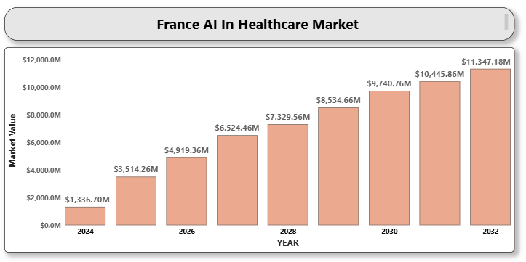

1. **Finland respiratory devices market**

**By Product Type (**Therapeutic Devices-Inhalers (Metered Dose and Dry Powder), Nebulizers, Oxygen Concentrators, Ventilators, CPAP and BiPAP Devices. Monitoring Devices-Pulse Oximeters, Capnography Devices. Diagnostic Devices-Spirometers, Peak Flow Meters). **By Indication (**Asthma, Chronic Obstructive Pulmonary Disease (COPD), Sleep Apnea, Respiratory Infections, Others). **By End User (**Hospitals, Home Healthcare, Ambulatory Surgical Centers, Clinics). **By Region** (Southern Finland, Western Finland, Northern and Eastern Finland). Global and Regional Industry Overview, Market Intelligence, Comprehensive Analysis, Hystorical Data, and forecastes 2024-2032.

According to Intelli, the Finland respiratory devices market was valued at USD 8986 million in 2024 and is expected to reach USD 13894.57 million by 2032, growing at a CAGR of 6.5% from 2024 to 2032.

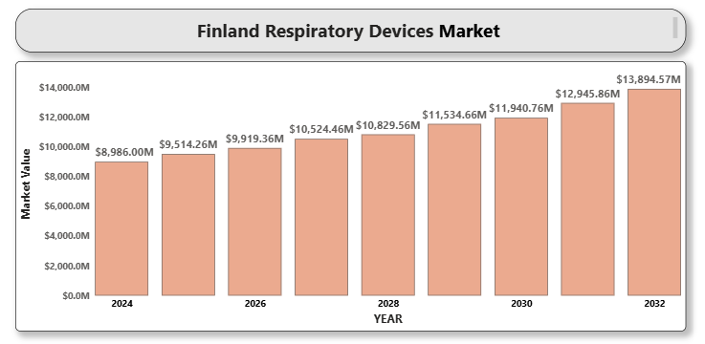

1. **EUROPE WHEELCHAIRS MARKET**

**By Product Type** (Manual Wheelchairs, Powered Wheelchairs). **By Category** (Basic Wheelchairs, Sports Wheelchairs, Pediatric Wheelchairs, Bariatric Wheelchairs). **By End User** (Hospitals, Home Care Settings, Rehabilitation Centers, Others (Clinics, Elderly Care Homes)). By Country(Germany, France, United Kingdom, Italy, Spain, Netherlands, Sweden, Poland, Belgium, Switzerland, Austria, Denmark, Norway, Rest of Europe). Global and Regional Industry Overview, Market Intelligence, Comprehensive Analysis, Hystorical Data, and forecastes 2024-2032.

According to Intelli, the Europe wheelchairs market was valued at USD 1,555.72 million in 2024 and is projected to reach USD 2374.72 million by 2032, growing at a CAGR of 6.33% during the forecast period of 2024-2032.

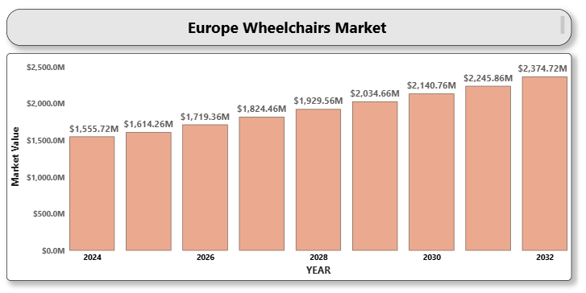

1. **Europe Injectable Drug Delivery Market**

**By Product Type (D**evices-Conventional Syringes, Prefilled Syringes, Autoinjectors, Pen Injectors, Needle-free Injectors. Formulations-Conventional Drugs, Biologics and Biosimilars, Vaccines). **By Application (**Oncology, Autoimmune Disorders, Hormonal Disorders, Cardiovascular Diseases, Infectious Diseases, Others). **By End-user (**Hospitals, Homecare Settings, Ambulatory Surgical Centers, Clinics). **By Country (**Germany, UK, France, Italy, Spain, Rest of Europe). Global and Regional Industry Overview, Market Intelligence, Comprehensive Analysis, Hystorical Data, and forecastes 2024-2032.

According to Intelli, the Europe Injectable Drug Delivery Market was valued at approximately USD 5,841 million in 2024 and is projected to reach USD 14154.14 million, growing at a compound annual growth rate (CAGR) of 12.6% during the forecast period (2024–2032).

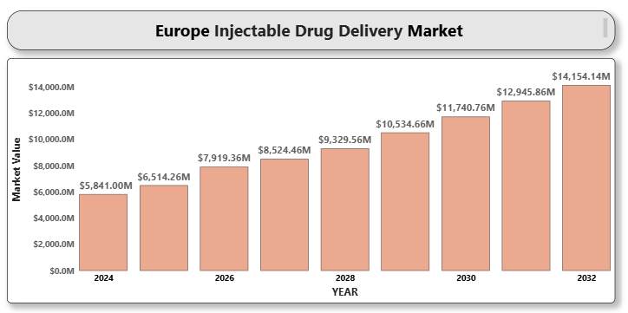

1. **EUROPE HOSPITAL BEDS MARKET**

**By Type** (Manual Beds, Semi-Electric Beds, Electric Beds). **By Application** (Acute Care Beds, Long-Term Care Beds, Psychiatric Care Beds, Maternity Beds, Others). **By Usage** (General Purpose Beds, ICU Beds, Pediatric Beds, Bariatric Beds). **By End Use** (Hospitals, Ambulatory Surgical Centers, Nursing Homes & Long-Term Care Facilities, Home Care Settings). **By Country (**Germany, UK, France, Italy, Spain, Rest of Europe). Global and Regional Industry Overview, Market Intelligence, Comprehensive Analysis, Hystorical Data, and forecastes 2024-2032.

According to Intelli, the Europe hospital beds market was valued at USD 2.95 billion in 2024 and is projected to reach USD 4.27 billion by 2032, growing at a CAGR of 4.8% during the forecast period.

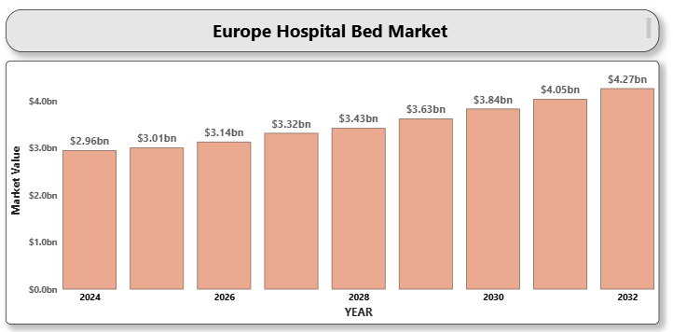

1. **Europe General Surgical Devices Market**

**By Product Type** (Handheld Devices, Electrosurgical Devices, Closure Devices, Laparoscopic Instruments, Others). **By Application (**Cardiovascular Surgery, Neurosurgery, Orthopedic Surgery, Gynecology and Urology, General Surgery, Others). **By End-user (**Hospitals, Ambulatory Surgical Centers, Specialty Clinics). **By Country (**Germany, UK, France, Italy, Spain, Rest of Europe). Global and Regional Industry Overview, Market Intelligence, Comprehensive Analysis, Hystorical Data, and forecastes 2024-2032.

According to Intelli, the Europe General Surgical Devices Market size was valued at approximately USD 4577.7 million in 2024 and is projected to reach USD 8024.94 million at a compound annual growth rate (CAGR) of 8.17% over the forecast period from 2024 to 2032.

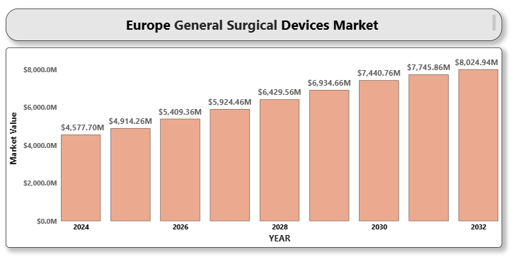

1. **Europe Diagnostic Imaging Devices Market**

**By Product Type (**X-ray Imaging Systems , Magnetic Resonance Imaging (MRI), Computed Tomography (CT) Scanners, Ultrasound Imaging, Nuclear Imaging Systems, Others ). **By Application (**Oncology, Cardiology, Neurology, Orthopedics, Obstetrics & Gynecology, Others). **By End-user (**Hospitals, Diagnostic Imaging Centers, Ambulatory Surgical Centers, Mobile Imaging Services). **By Country (**Germany, UK, France, Italy, Spain, Rest of Europe ). Global and Regional Industry Overview, Market Intelligence, Comprehensive Analysis, Hystorical Data, and forecastes 2024-2032.

According to Intelli, the Europe Diagnostic Imaging Devices Market was valued at approximately USD 9030 million in 2024 and is projected to reach USD 136177.33 million by 2032 at a compound annual growth rate (CAGR) of 6.17% during the forecast period (2024–2032).

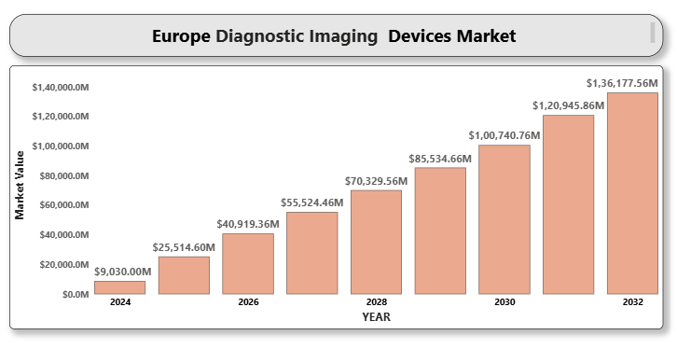

1. **Europe Dental Devices Market**

**By Product Type (**General and Diagnostic Equipment, Dental Consumables, Other Dental Devices). **By Treatment (**Orthodontic, Endodontic, Periodontic, Prosthodontic, Restorative and Preventive Dentistry). **By End-user (** Hospitals, Dental Clinics, Academic and Research Institutes, Dental Laboratories). **By Country (**Germany, United Kingdom, France, Italy, Spain, Rest of Europe). Global and Regional Industry Overview, Market Intelligence, Comprehensive Analysis, Hystorical Data, and forecastes 2024-2032.

According to Intelli, Europe Dental Devices Market was valued at approximately USD 8,733 million in 2024 and is projected to reach USD 15842.56 million, growing at a compound annual growth rate (CAGR) of 8.63% over the forecast period from 2025 to 2032.

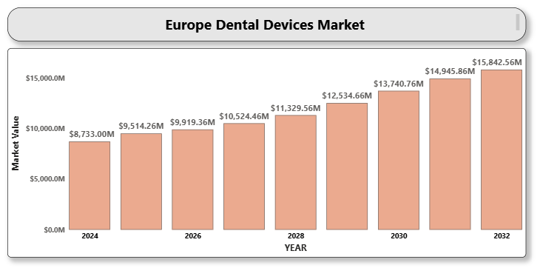

1. **Europe Cardiology Devices Market**

**By Product Type** (Diagnostic and Monitoring Devices-ECG Devices, Holter Monitors, Event Monitors, Implantable Loop Recorders. Therapeutic and Surgical Devices-Pacemakers, Defibrillators, Cardiac Resynchronization Therapy (CRT) Devices, Catheters and Stents, Heart Valves. **By Application (**Coronary Artery Disease, Heart Failure, Arrhythmia, Hypertension, Others). **By End-user (**Hospitals, Cardiology Clinics, Ambulatory Surgical Centers, Homecare Settings). **By Country (**Germany, UK, France, Italy, Spain, Rest of Europe). Global and Regional Industry Overview, Market Intelligence, Comprehensive Analysis, Hystorical Data, and forecastes 2024-2032.

According to Intelli, the Europe Cardiology Devices Market was valued at approximately USD 15823.33 million in 2024 and is projected to reach USD 28762.73 million by 2032, growing at a compound annual growth rate (CAGR) of 6.71% during the forecast period (2024–2032).

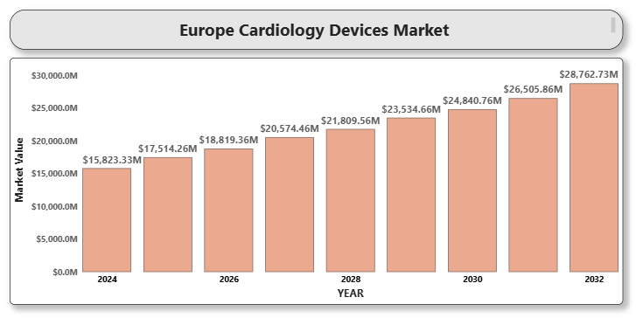

1. **EUROPE 3D-PRINTED PROSTHETICS MARKET**

**By Product Type** (Upper Limb Prosthetics, Lower Limb Prosthetics, Sockets, Liners, Others).  **By End User** (Hospitals, Prosthetic Clinics, Rehabilitation Centers, Homecare Settings). **By Technology** (Stereolithography, Selective Laser Sintering (SLS), Fused Deposition Modeling (FDM),Others). **By Application** (Pediatric Prosthetics, Adult Prosthetics, Athletic/Sports Prosthetics). **By Country (**Germany, UK, France, Italy, Spain, Rest of Europe). Global and Regional Industry Overview, Market Intelligence, Comprehensive Analysis, Hystorical Data, and forecastes 2024-2032.

According to Intelli, the Europe 3D-printed prosthetics market was valued at USD 1,559.73 million in 2024 and is projected to reach USD 3017.57 million by 2032, growing at a CAGR of  9.5% from 2025 to 2032.

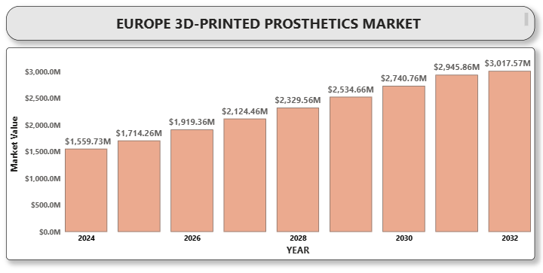

1. **Denmark Ophthalmic Devices Market**

**By Product Type (**Diagnostic Devices, Cataract Surgery Equipment, Glaucoma Treatment Devices, Refractive Surgery Devices, Others). B**y Application (**Cataract Surgery, Glaucoma Treatment, Retinal Disorders, Vision Correction, Other Applications). B**y End User (**Hospitals, Ophthalmology Clinics, Ambulatory Surgical Centers, Research and Academic Institutes). **By Region (**Northern Denmark, Central Denmark, Southern Denmark). Global and Regional Industry Overview, Market Intelligence, Comprehensive Analysis, Hystorical Data, and forecastes 2024-2032.

According to Intelli, the Denmark ophthalmic devices market was valued at USD 109.1million in 2024 and is projected to reach USD 151.61 million by 2032, growing at a CAGR of 5.1% from 2024 to 2032.

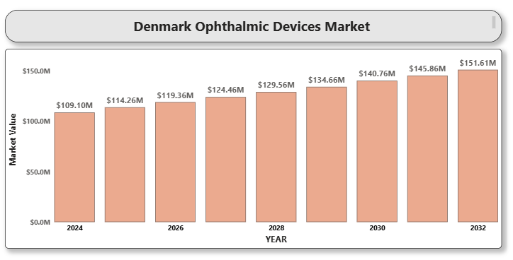

1. **Czech Republic Dental Devices Market**

**By Product Type (Diagnostic Devices**-X-ray systems, Intraoral cameras. **Therapeutic Devices**-Dental implants, Orthodontic devices, Endodontic devices, Dental lasers. **Preventive Devices**-Teeth whitening products, Fluoride treatments. **Restorative Devices**-Crowns and bridges, Dentures, Fillings). B**y End User (**Hospitals, Dental Clinics, Homecare, Research and Educational Institutions). **By Region (**Prague and Central Bohemia, South Moravian Region, Other regions). Global and Regional Industry Overview, Market Intelligence, Comprehensive Analysis, Hystorical Data, and forecastes 2024-2032.

According to Intelli, the Czech Republic dental devices market was valued at USD 950 million in 2024 and is expected to reach USD 1361 million by 2032, growing at a CAGR of 5.5% from 2024 to 2032.

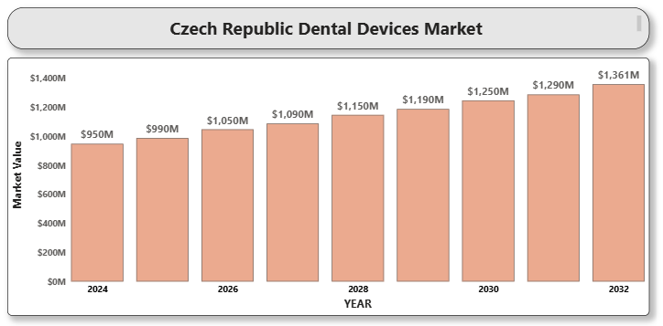

1. **CYPRUS MEDICAL DEVICES MARKET**

**By Product Type** (Diagnostic Imaging Devices, Patient Monitoring Devices, Surgical Devices, Respiratory Devices, Orthopedic Devices, Home Healthcare Devices). **By End-User** (Hospitals, Diagnostic Centers, Ambulatory Surgical Centers (ASCs), Homecare Settings). **By Technology** (Digital Health Technologies, Minimally Invasive TechnologiesRobotic Technologies, Wearable Devices)**. By Application** (Cardiology, Orthopedics, Respiratory, Neurology, Oncology).Global and Regional Industry Overview, Market Intelligence, Comprehensive Analysis, Hystorical Data, and forecastes 2024-2032.

According to Intelli, the Cyprus medical devices market was valued at USD 131.18 million in 2024 and is projected to reach USD 196.62 million by 2032, growing at a CAGR of 6.09% from 2024 to 2032.

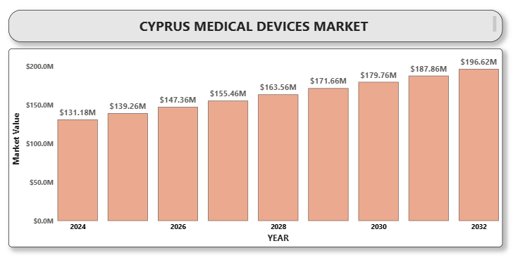

1. **BOSNIA DENTAL DEVICES MARKET**

**By Product Type (**Dental Instruments**,** Imaging Systems**,** Dental Lasers**,** Dental Chairs and Equipment**,** Other Accessories**). By End-User (**Dental Clinics**,** Hospitals**,** Research and Academic Institutions). **By Technology (**Digital Dentistry (CAD/CAM Systems)**,** Laser Dentistry**,** 3D Imaging and Intraoral Cameras).**By Application (**General Dentistry**,** Orthodontics**,** Cosmetic Dentistry**,** Implants and Prosthetics**,** Other Applications). **By Region** ( Sarajevo Region, Tuzla Region, Zenica-Doboj Region, Herzegovina-Neretva Region, Una-Sana Region, Central Bosnia Region, Republika Srpska Region, Brčko District). Global and Regional Industry Overview, Market Intelligence, Comprehensive Analysis, Hystorical Data, and forecastes 2024-2032.

According to Intelli, the Bosnia dental devices market was valued at USD 6 million in 2024 and is projected to reach USD 10.78 million by 2032, growing at a CAGR of 8.5% from 2024 to 2032.

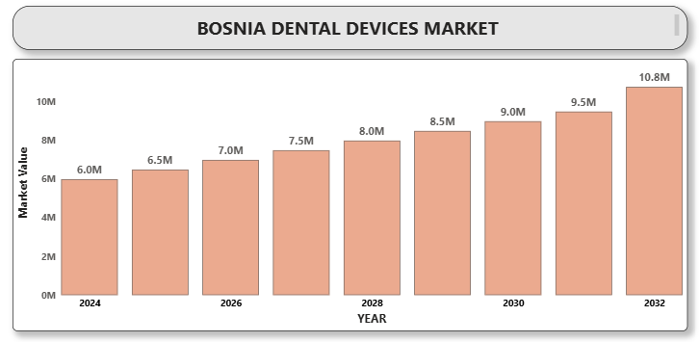

1. **Belgium Cardiology Devices Market**

**by Product Type (**Diagnostic and Monitoring Devices-ECG Devices, Holter Monitors, Event Monitors, Implantable Loop Recorders, Echocardiograms, Cardiac MRI and CT. Therapeutic and Surgical Devices-Pacemakers, Defibrillators, Stents, Catheters, Heart Valves). **By Application (**Coronary Artery Disease, Heart Failure, Cardiac Arrhythmia, Congenital Heart Disease, Other Applications). By **End User (**Hospitals, Cardiac Centers, Ambulatory Surgical Centers, Diagnostic Laboratories). **By Region (**Flanders, Wallonia, Brussels Capital Region). Global and Regional Industry Overview, Market Intelligence, Comprehensive Analysis, Hystorical Data, and forecastes 2024-2032.

According to Intelli, the Belgium cardiology devices market was valued at USD 516.5 million in 2024 and is projected to reach USD 675.88 million by 2032, growing at a CAGR of 4.32% from 2024 to 2032.

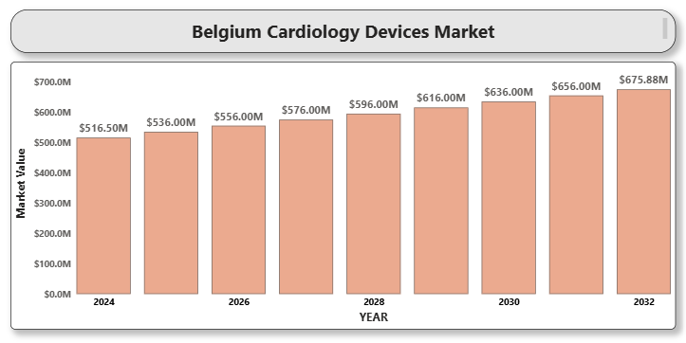

# AUSTRIA MEDICAL IMAGING EQUIPMENT MARKET

**By Product Type** (X-ray Imaging Systems, Ultrasound Systems, MRI Equipment, CT Scanners, Nuclear Imaging Equipment (PET & SPECT)**.** **By End User** (Hospitals, Diagnostic Imaging Centers, Ambulatory Surgical Centers, Others). **By Region (**Eastern Austria, Western Austria). Global and Regional Industry Overview, Market Intelligence, Comprehensive Analysis, Hystorical Data, and forecastes 2024-2032.

According to Intelli, the Austria Medical Imaging Equipment Market was valued at USD 239.45 million in 2024 and is projected to reach USD 308.05 million by 2032, growing at a CAGR of 6.3% during the forecast period.

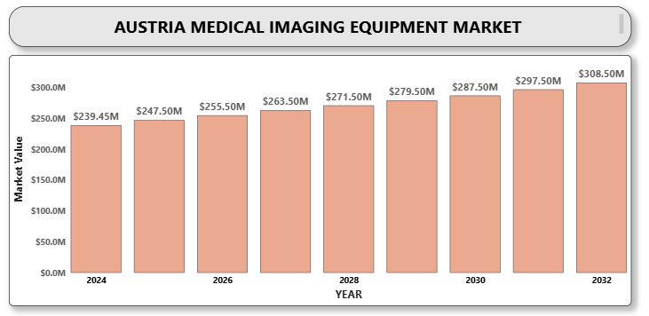

1. **Austria Diabetes Care Devices Market**

**by Product** **Type (**Blood Glucose Monitoring Devices -Self-Monitoring Blood Glucose (SMBG) Devices, Continuous Glucose Monitoring (CGM) Devices, Insulin Delivery Devices, Insulin Pens, Insulin Pumps, Others). B**y Distribution Channel (**Hospital Pharmacies, Retail Pharmacies, Online Pharmacies, Diabetes Clinics). B**y End User (**Hospitals, Homecare Settings, Diagnostic Centers). B**y Region (**Eastern Austria, Western Austria). Global and Regional Industry Overview, Market Intelligence, Comprehensive Analysis, Hystorical Data, and forecastes 2024-2032.

According to Intelli, the Austria diabetes care devices market was valued at USD 162.91 million in 2024 and is projected to reach USD 324.11 million by 2032, growing at a CAGR of 9.88% from 2024 to 2032.

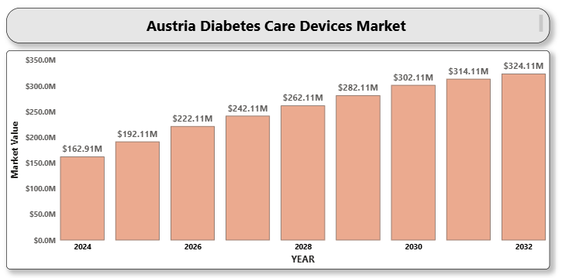

1. **BELGIUM HEARING AIDS MARKET**

**By Product Type (**Behind-the-Ear (BTE) Hearing Aids**,** In-the-Ear (ITE) Hearing Aids**,** Receiver-in-the-Ear (RITE) Hearing Aids**,** In-the-Canal (ITC) and Completely-in-Canal (CIC)**,** Others (Body-worn, Invisible-in-Canal)). **By Technology (**Analog Hearing Aids**,** Digital Hearing Aids**,** By Distribution Channel**,** Audiology Clinics and Hearing Centers**,** ENT Clinics and Hospitals**,** Retail and Online Stores).  **By Patient Type (**Adult, Pediatric). **By Region (**Flanders, Wallonia, Brussels Capital Region). Global and Regional Industry Overview, Market Intelligence, Comprehensive Analysis, Hystorical Data, and forecastes 2024-2032.

According to Intelli, the Belgium Hearing Aids Market was valued at USD 70.2 million in 2024 and is projected to reach USD 120.3 million by 2032, growing at a CAGR of 8.3% during the forecast period.

